Life Insurance Beneficiary Change
- Welcome to the KHRIS ESS –Life Insurance Beneficiary Change tutorial. This tutorial will show you how to designate primary and secondary beneficiaries to a life insurance plan.
- In order to add a beneficiary to your life insurance, you must first add the beneficiaries to the “Dependents and Beneficiaries” holding place by selecting the icon below.
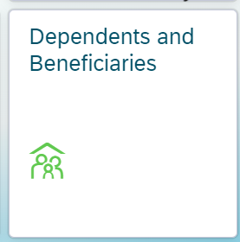
- Once you have selected that icon you will be brought to a new page that looks as follows. 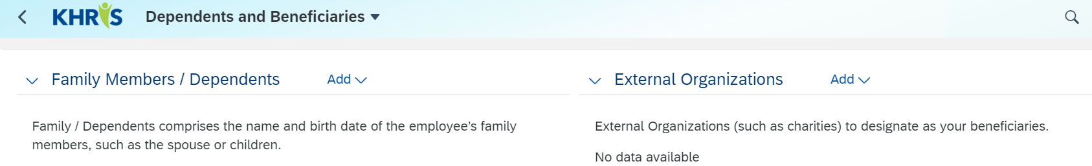
- If you are trying to add an individual person as your beneficiary select the “Add” option directly to the right of the “Family Members/Dependents” option and select between the listed options of Spouse, Child or Other Beneficiary.
  - If you are trying to add an organization as your beneficiary select the “Add “option directly to the right of the “External Organizations” option and select between the listed options of Charity Organization or Trust Fund. (please note that if you are listing an external organization that you will need to provide a tax ID number)
- Once you have selected the Spouse, Child or Other Beneficiary option, you should see a new page that looks as follows.
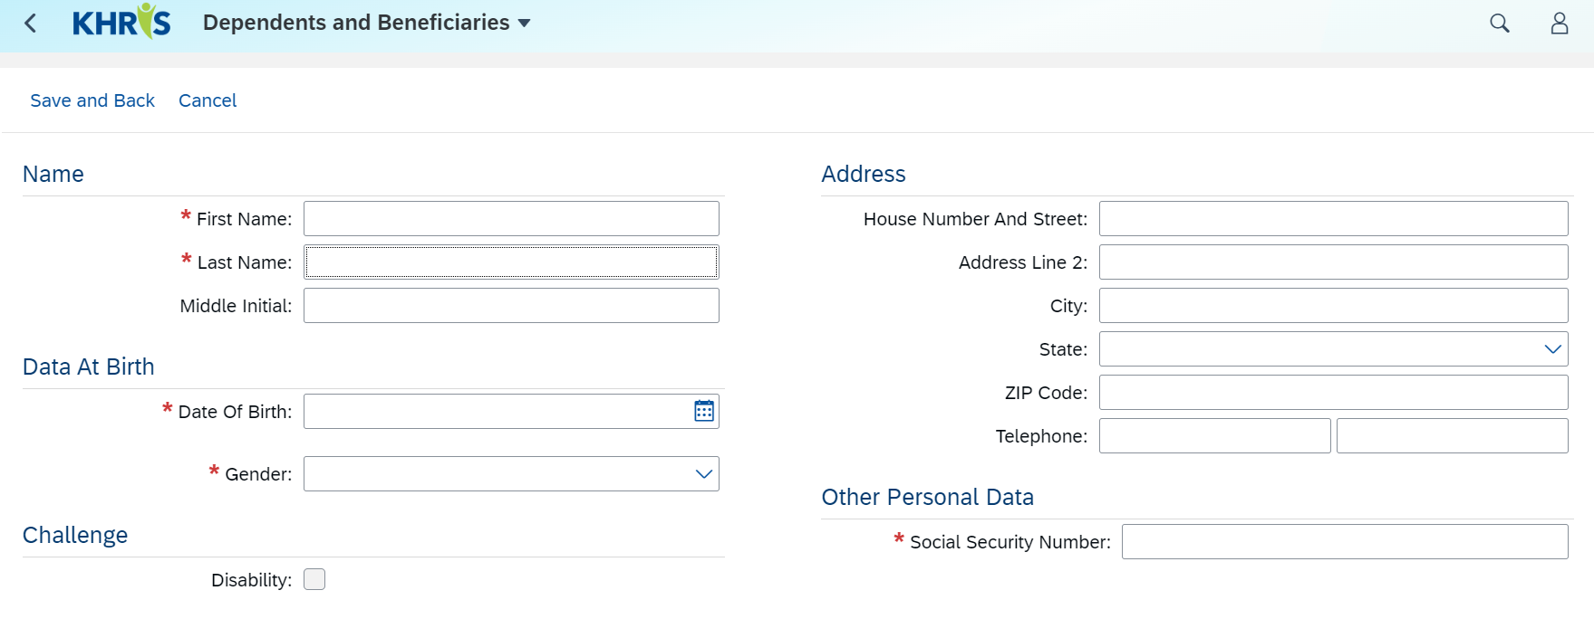
- Fill in all the information on that individual. Any line with a red asterisk mark is a required field.
- Once all sections have been completed, click on the “Save and Back” and repeat for however many other beneficiaries you are going to add to your plans.
- Once you have added all of your beneficiaries, you will select the back button up by the KHRIS Logo in the top left corner of your screen. *see below*
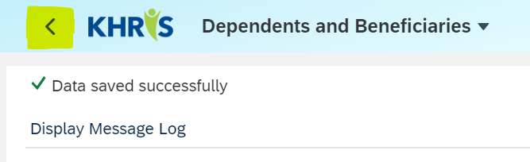
- Once selected that will bring you back to your KHRIS ESS home page, where you will navigate to the next step to add these individuals to your life insurance plans.
- Now select the “Life Insurance Beneficiary Change” box
- Once selected you should see the page below
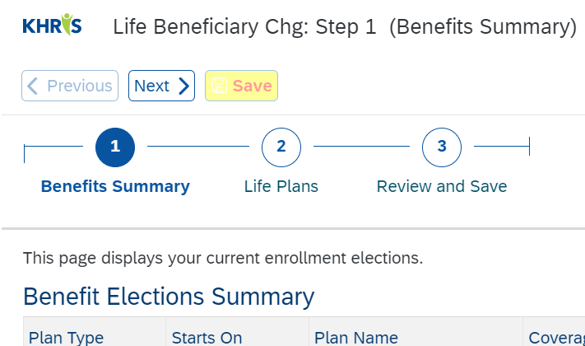
- Click on the “Life Plans (#2)” option
- Select the Edit icon for the life insurance plan you are changing the beneficiaries for
- Once you have selected the edit icon, you should see the below pop-up appear
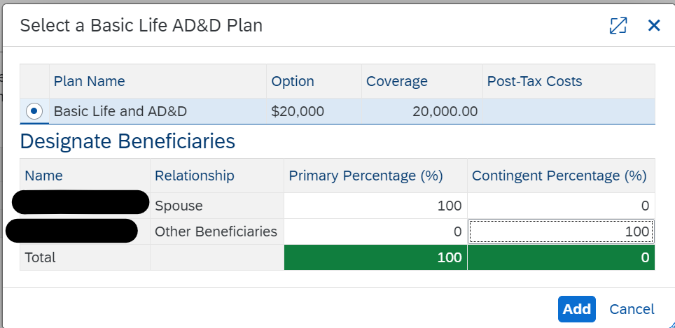
- In this pop-up, you will need to assign the percentages for your primary and contingent (secondary) beneficiaries. Both columns will need to add up to 100%. Also, you must use whole numbers. If any family member or other beneficiary is listed in there but you do not want any percentage going to them, make sure both columns read as 0% for that individual.
- Once you have made all your changes and everything is correct, then click the blue “Add” button.
- The pop-up should then close down and you will repeat this process for any remaining life insurance plans you were wanting to update
- Click on the “Review and Save (#3)” option
- This will bring you to a new page that will have you review your changes to your plans.
- If everything looks correct click on the yellow “Save” option.
- Then click on the “Close” button to complete your beneficiary change and to get back to your KHRIS ESS home page.

